**Docker introduction**

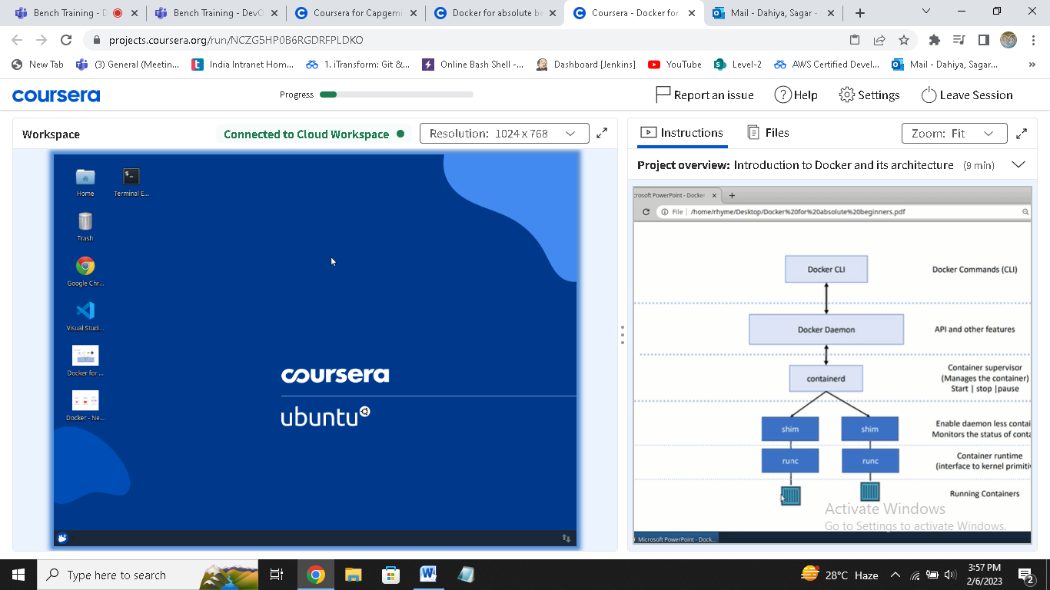

**Docker daemon : manage api feature**

**Containerd : container supervisor (manage i.e start,stop,pause)**

**Shim : monitor status of container (enable daemon less container)**

**Runc : container runtime**

**Container : running container**

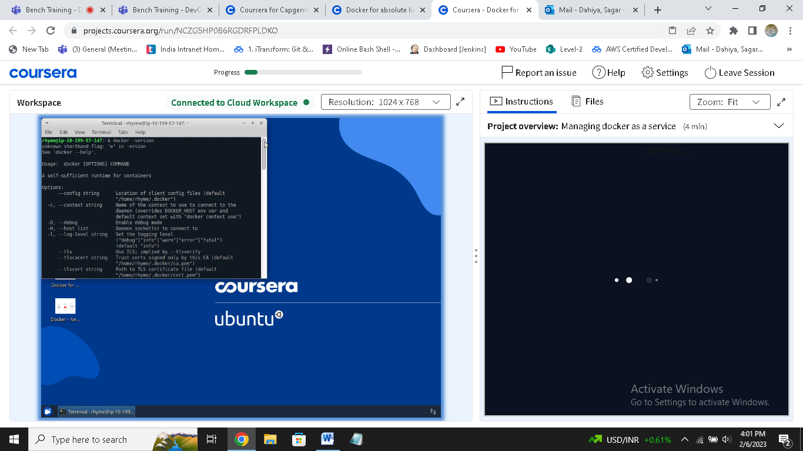

**Docker –version : to check docker installed or not**

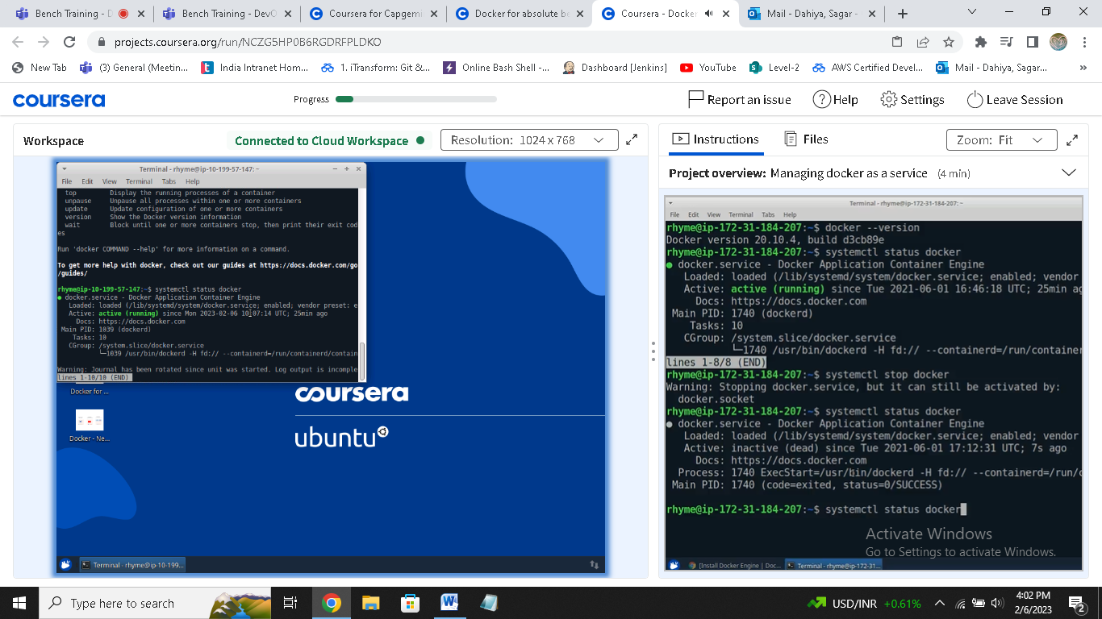

**systemctl docker status : to check docker run or stop**

sudo dockerd :to start docker daemon

sudo dockerd –debug : to run docker in debugging mode

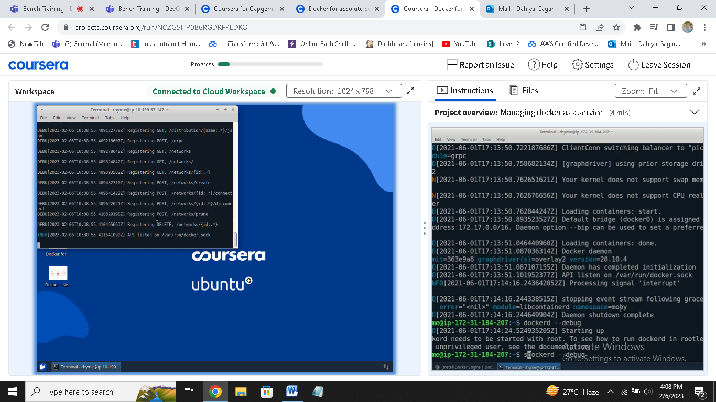

**Docker ps –a : to check running container**

**Docker ps : to check all**

**Docker container prune : to delete all stopped container**

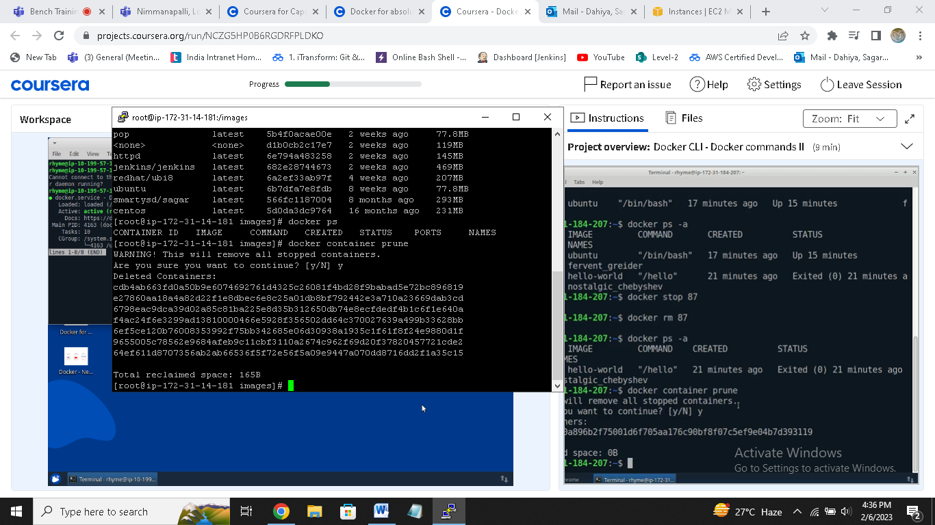

**Docker rmi imagename:to delete images**

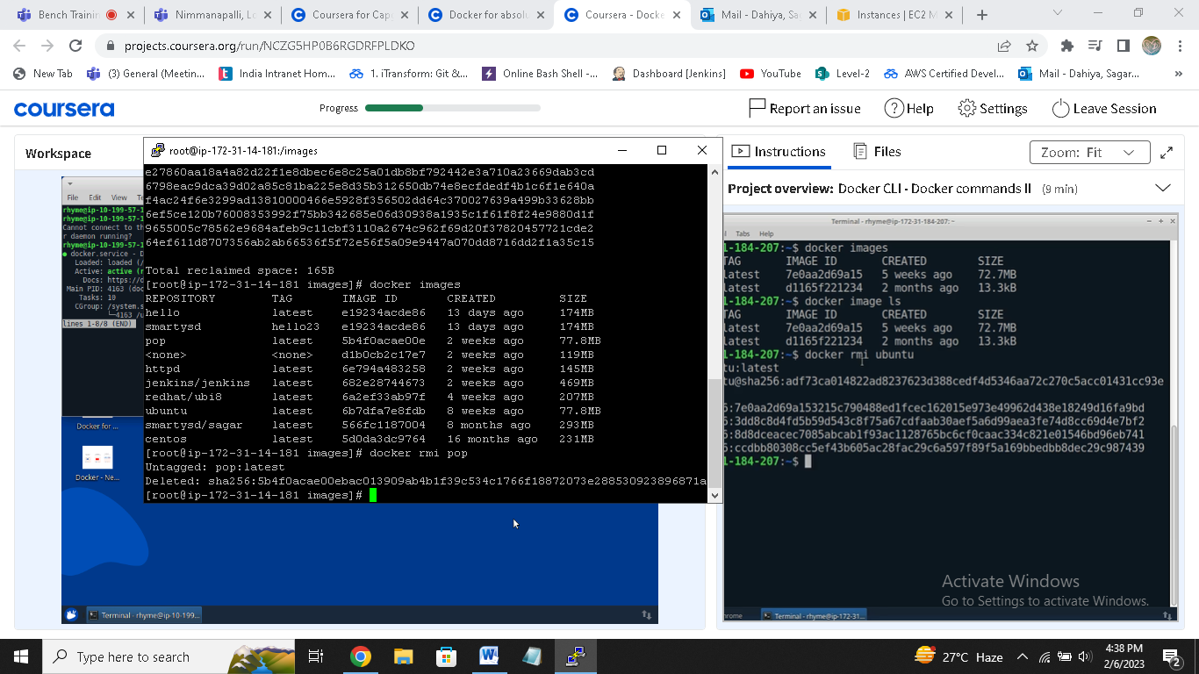

**Docker run –it Ubuntu : to run in interactive mode**

**Docker run –itd Ubuntu : to run detach mode**

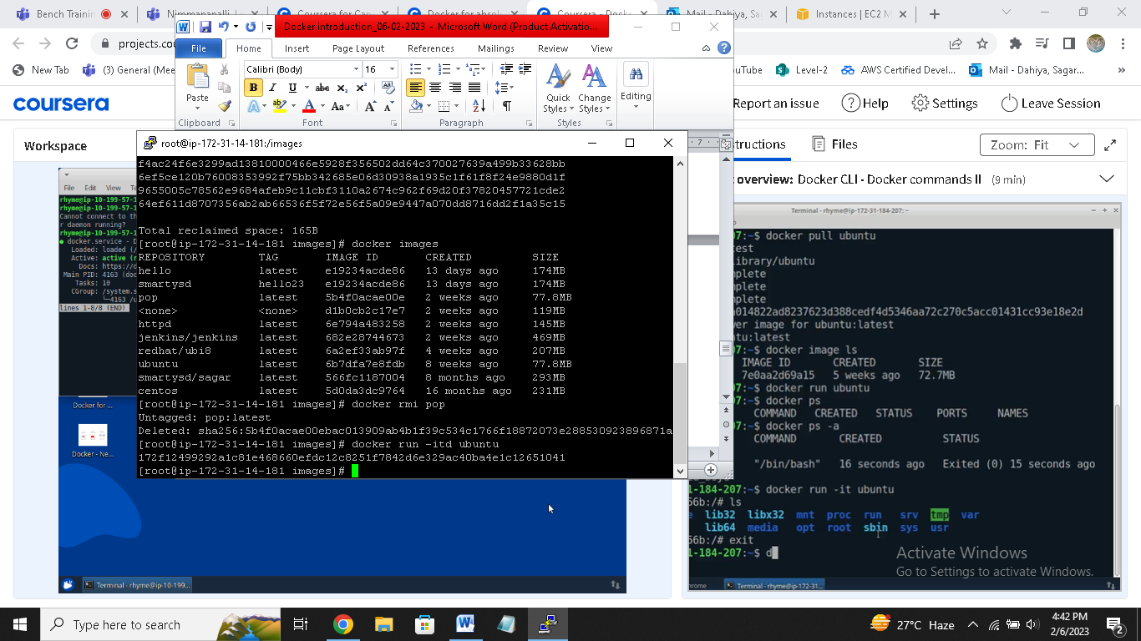

**Docker exec –it containerid /bin/bash : to go into running container**

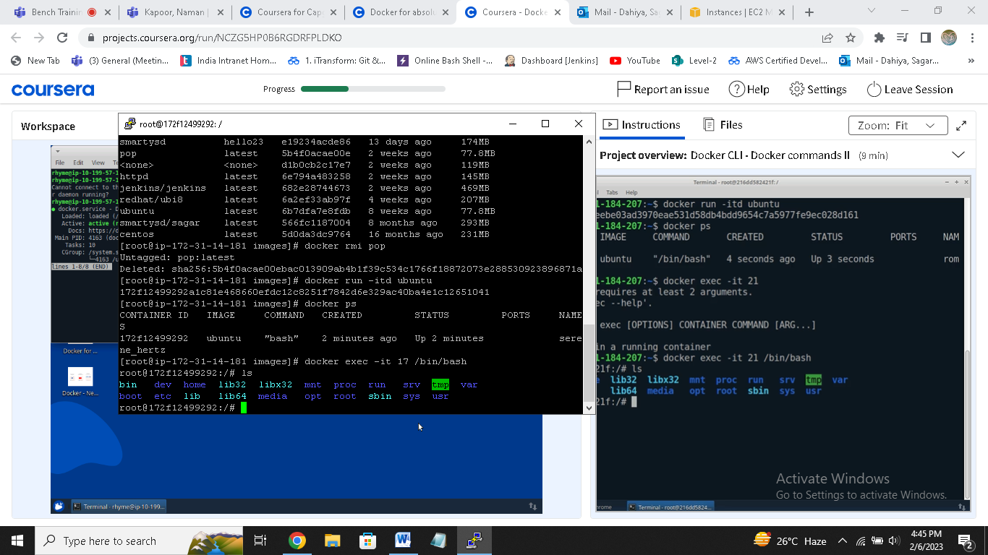

**Docker inspect containerid : to know about container**

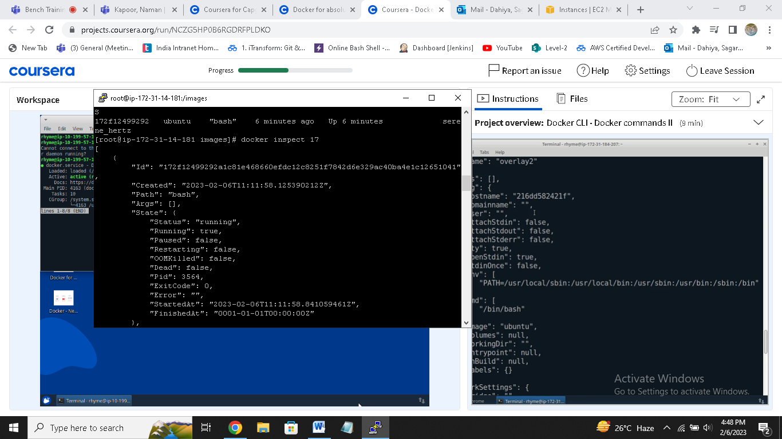

**Docker inspect imageid : information about image**

**docker run -d -p 80:8080 jenkins/Jenkins { to run Jenkins }**

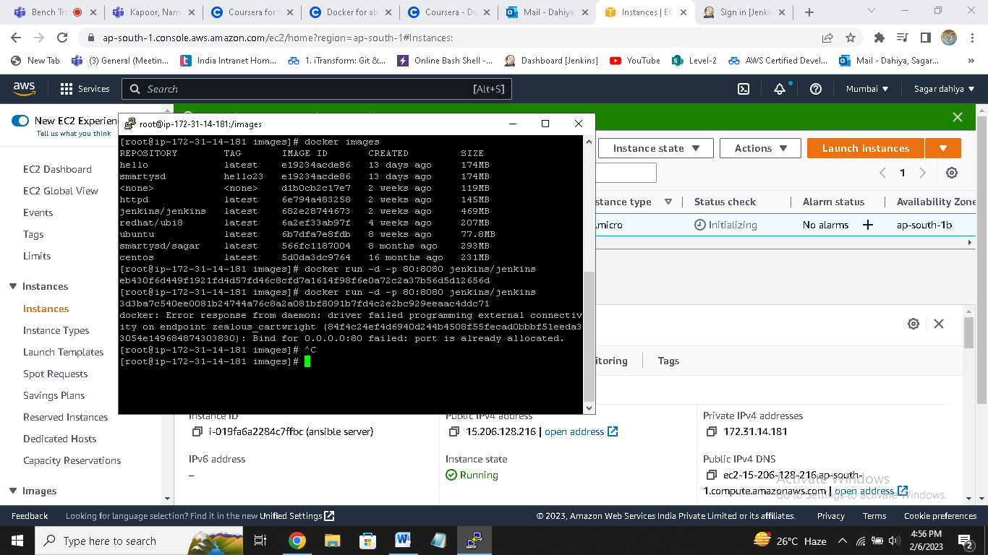

**Now go to publicip:80 to check Jenkins**

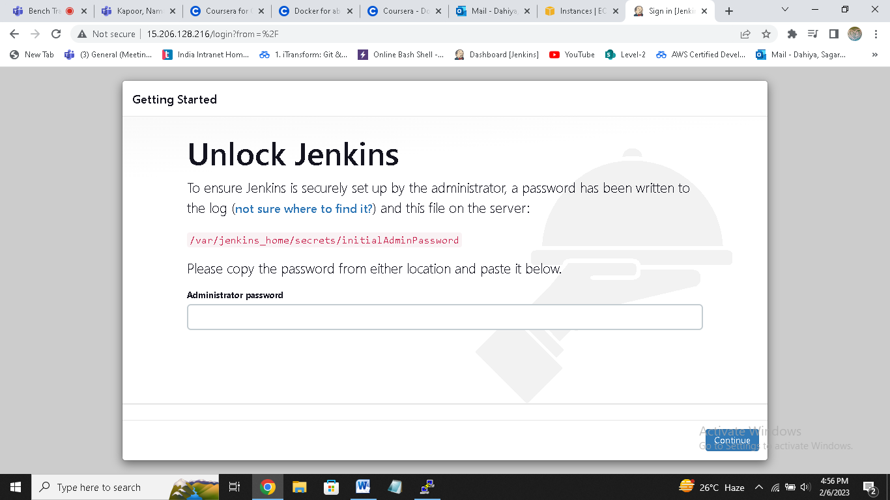

**Docker network ls : to show all networks**

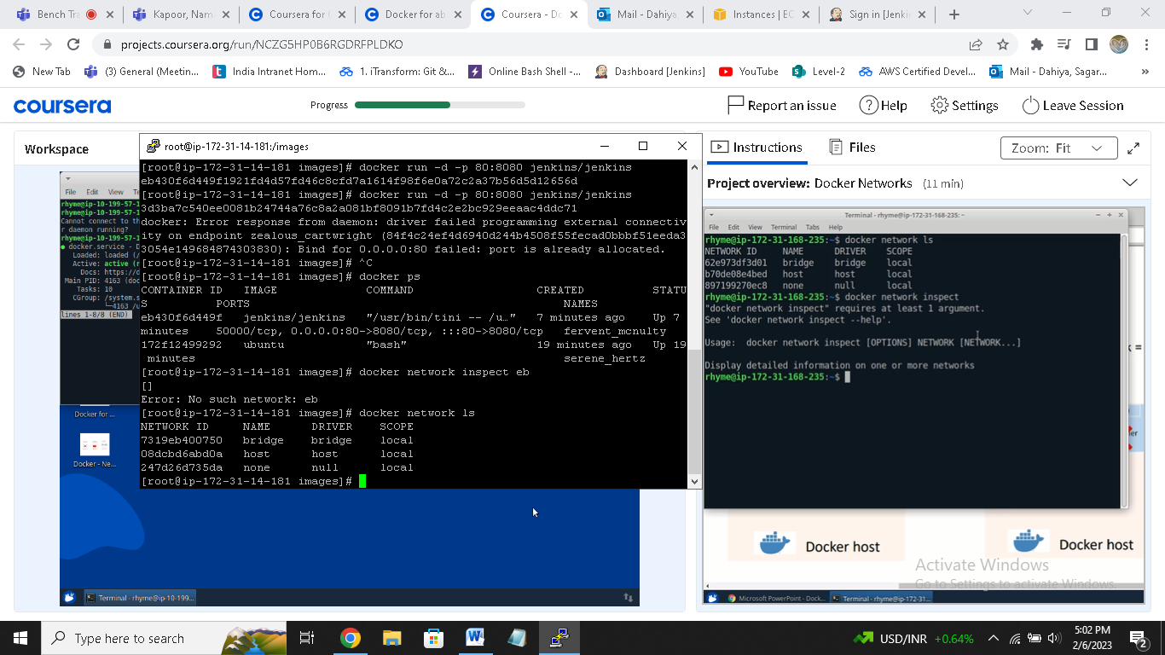

**Ip link : to show ip address**

**Ip addr : to show address allocated**

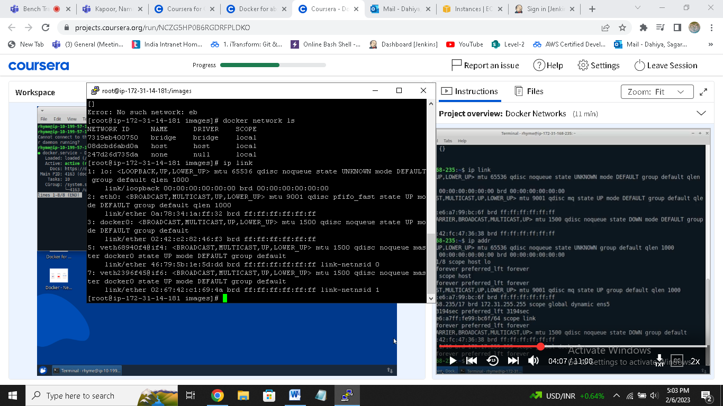

**Docker network create --driver=bridge --subnet=182.1.0.1/16 isolated**

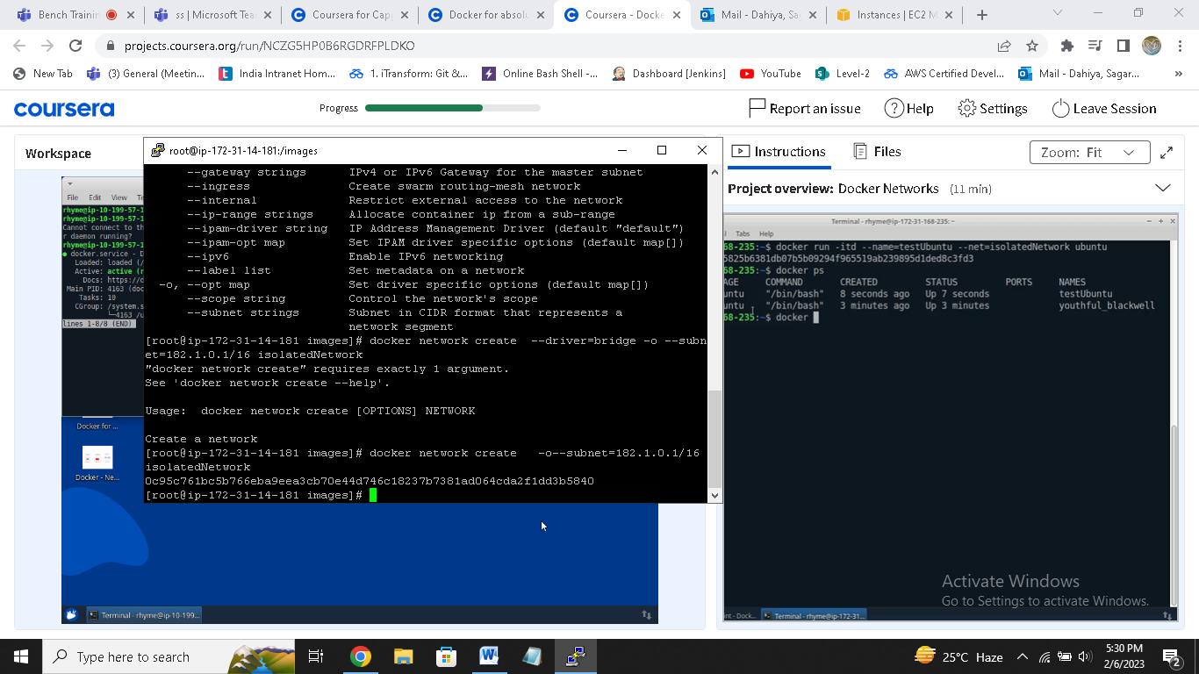

**Docker run –itd –name=test1 –net=isolated Ubuntu**

**Docker inspect containerid**

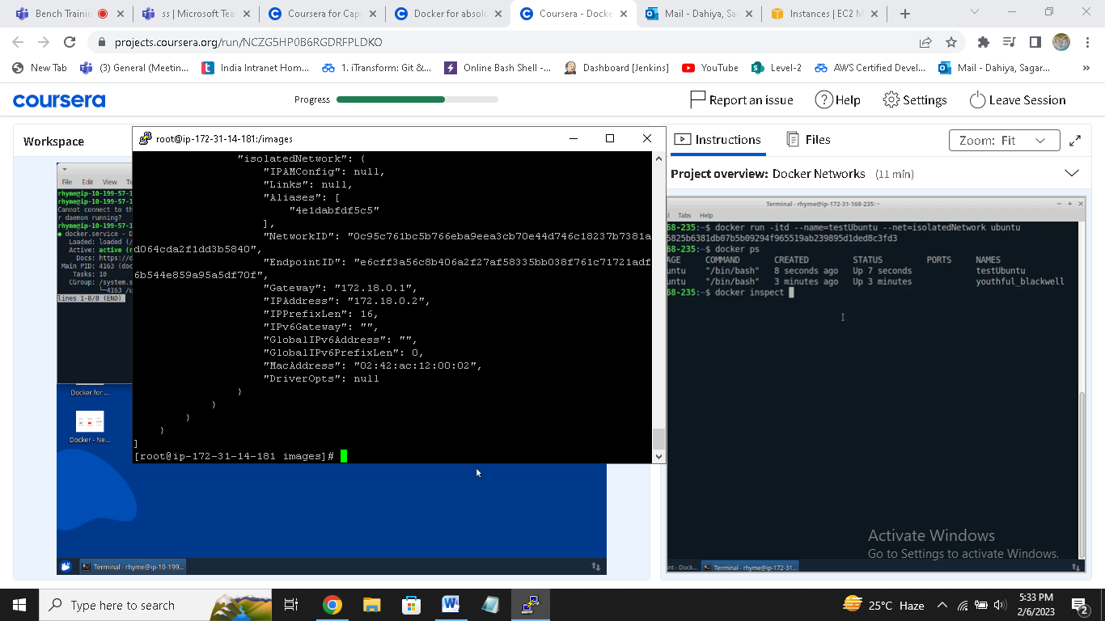

**Docker network connect isolatedNetwork containerid**

**Docker network disconnect isolatesNetwork containerid**

